Live Polling App (.NET SignalR + React) — PRD
Nov 7, 2026 · @momo

Overview
Live Polling lets a host create a poll, share a short join code, and watch every vote appear on all connected screens within a second. It is built with ASP.NET Core and SignalR on the server and React with TypeScript in the browser.
The project doubles as a portfolio piece. It is small enough to finish in roughly five weeks of part-time work (proposed), yet it covers real-time messaging, authentication, persistence, testing and deployment.

Problem and goals
Polls in classes, meetings and live streams are usually run by show of hands, or with form tools where results only appear after a refresh or after voting closes. People want to see the room's answer as it forms.
The project commits to five outcomes (targets are proposed):
- Votes reach every connected screen in under 500 ms (p95) with 200 clients on one instance.
- A voter joins and votes in under 10 seconds, with no account.
- A host controls the poll lifecycle: draft, open, closed.
- One vote per voter per poll, enforced by the database and not only the UI.
- The builder learns SignalR groups, strongly typed hubs, EF Core, JWT auth, React with a SignalR client, Docker and CI.

Users and use cases
Three roles use the app, and only the host needs an account.
Role | Who | What they need
Host | Teacher, meeting lead, meetup organizer, streamer | Create a poll, open and close voting, see results as they arrive
Voter | Student, colleague, audience member on a phone | Join from a code or link and vote in a few taps, then see results
Presenter view | The host's second screen or a projector | Large, readable live results with the join code visible
Typical scenarios: a quick comprehension check in class, a team retro vote, a meetup Q&A topic vote, and a stream audience choosing the next topic.

Scope
The MVP is single-choice polls with live results for anonymous voters and hosts who sign in. Everything else waits for a later version.
Capability | Release
Host sign-up and login | MVP
Create a poll with a question and 2 to 10 options | MVP
Join by 6-character code or link, no account | MVP
Single-choice voting, one vote per voter | MVP
Live results on every screen | MVP
Host opens and closes voting | MVP
Presenter view for a projector | MVP
Online voter count (presence) | Later
Multiple choice, ranked choice, word cloud | Later
Timers and auto-close | Later
CSV export of results | Later
Redis backplane for more than one server instance | Later
Non-goals: a general chat app, payments, native mobile apps, moderation of free-text answers, and proof that each voter is a unique person (the MVP limits one vote per browser).

User stories and functional requirements
Eight requirements are must-haves; the rest ship if time allows.
ID | Story | Priority
F1 | As a host, I can register and log in with email and password. | Must
F2 | As a host, I can create a poll with a question and 2 to 10 options. | Must
F3 | As a host, I get a join code and a shareable link; a new poll starts in Draft. | Must
F4 | As a host, I can open and close voting. | Must
F5 | As a voter, I can join with a code or link without an account. | Must
F6 | As a voter, I can cast one vote per poll; changing it is not allowed in the MVP. | Must
F7 | As anyone in the poll, I see counts and percentages update live without refreshing. | Must
F8 | As a reconnecting client, I get the current results again after a dropped connection. | Must
F9 | As a host, I can open a presenter view with large bars for a projector. | Should
F10 | As a host, I can see how many voters are connected. | Should
F11 | As a host, I can duplicate or reset a poll. | Could
F12 | As a host, I can export results as CSV. | Could

Non-functional requirements
The app must feel instant and must not accept a second vote from the same voter. Numbers are proposed targets for one small server instance.
Area | Requirement
Latency | A vote shows on every connected screen in under 500 ms (p95) with 200 clients
Capacity | 1,000 concurrent connections on one small instance
Resilience | The client reconnects automatically and reloads current results
Integrity | A unique index on poll and voter rejects duplicate votes in the database
Security | Hashed passwords (ASP.NET Identity), JWT for hosts, HTTPS only, CORS limited to the app origin, rate limits on join and vote
Accessibility | Keyboard operable, results never shown by colour alone, WCAG 2.2 AA as the target
Privacy | No personal data stored for voters; hosts store only email and password hash
Operability | Structured logs and a health-check endpoint

Architecture and tech stack
The browser sends commands over REST and receives live results over SignalR; one PostgreSQL database is the source of truth. Votes go in through a REST endpoint so they are validated, rate-limited and tested like any request, and after saving, the server pushes new totals to that poll's SignalR group.
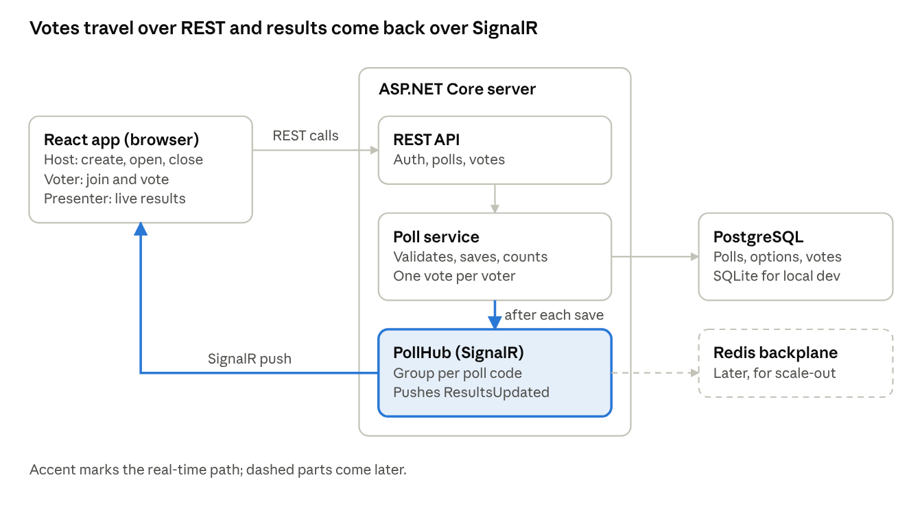
architecture · browser, server, database
The accent path is the real-time part: after the poll service saves a vote, PollHub pushes new totals to every browser in that poll.
Layer | Choice | Why
Frontend | React with TypeScript, built with Vite | Fast dev loop, typed models
Client data | TanStack Query and @microsoft/signalr | Query loads current results, push events patch the cache
API | ASP.NET Core Web API | Auth, poll management, voting
Real time | SignalR hub, one group per poll code | Only people in a poll receive its updates
Data | EF Core with PostgreSQL (SQLite for local dev) | Unique index enforces one vote per voter
Auth | ASP.NET Identity with JWT | Hosts only; voters stay anonymous
Delivery | Docker containers and GitHub Actions | Repeatable builds and tests
Scale-out (later) | Redis backplane for SignalR | Lets several server instances share broadcasts

Data model and real-time contract
Three tables plus the Identity user table hold everything; REST carries commands and SignalR carries only server-to-client events.
Entity | Key fields | Notes
Poll | Id, Code, Question, Status, OwnerId, CreatedAt, OpenedAt, ClosedAt | Status is Draft, Open or Closed; Code is unique, 6 characters
Option | Id, PollId, Text, Position | 2 to 10 per poll
Vote | Id, PollId, OptionId, VoterId, CreatedAt | Unique index on (PollId, VoterId); VoterId is a random ID the browser keeps in local storage

Kind | Name | Purpose | Who
REST | POST /api/auth/register, POST /api/auth/login | Create a host, return a JWT | Anyone
REST | POST /api/polls | Create a poll in Draft | Host
REST | POST /api/polls/{code}/open, POST /api/polls/{code}/close | Change status | Host who owns it
REST | GET /api/polls/{code} | Question, options, status and current totals | Anyone with the code
REST | POST /api/polls/{code}/votes | Cast a vote; returns 409 if the voter already voted, 400 if the poll is not open | Voter
Hub call | JoinPoll(code) | Add the connection to group poll-{code} | Anyone with the code
Hub event | ResultsUpdated(code, totals) | Pushed to the group after each saved vote | Group members
Hub event | StatusChanged(code, status) | Pushed when the host opens or closes voting | Group members

Success metrics and acceptance criteria
The MVP is done when every row below passes.
Metric | Target | How it is checked
Vote-to-screen latency | Under 500 ms (p95) with 200 simulated clients | Load-test script against one instance
Time to join and vote | Under 10 seconds from opening the link | Manual test on a phone
Duplicate votes accepted | 0 | Integration test that votes twice with the same voter ID
Reconnect | Results correct within 5 seconds of the network returning | Manual test: drop and restore the connection
Service-layer test coverage | At least 80% | xUnit run in CI
Delivery | Public URL, green CI pipeline, README with setup steps | Checklist at release
Acceptance in one line each: a closed poll rejects votes; a second vote from the same browser returns 409; two browsers on the same poll show the same totals after every vote.

Milestones, risks and open questions
Five one-week milestones take the project from an empty repo to a deployed app; the durations are proposed and can move.
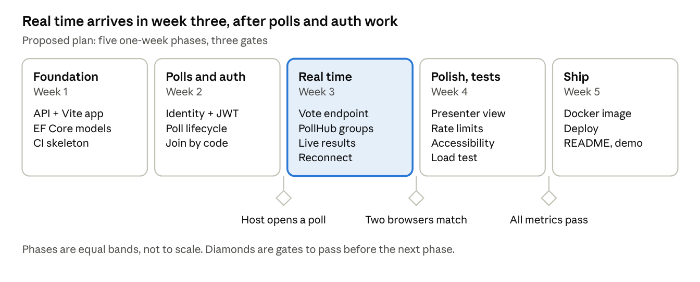
roadmap · 5 phases, 3 gates
Week three is the heart of the project: voting and the PollHub go live there, and the last gate is the success-metrics table above.

Risks
Risk | Impact | Mitigation
One vote per browser can be bypassed by clearing storage or switching browsers | Skewed results | Accept it in the MVP and say so; rate-limit voting; consider voter sign-in later
Many votes at once flood clients with updates | Laggy screens | Push totals, not individual votes, and coalesce bursts
Mobile connections drop | Stale results on screen | Automatic reconnect and a results refetch (F8)
Running more than one server instance | Missed broadcasts | Add the Redis backplane before scaling out
Scope creep toward chat features | Missed schedule | Keep the Non-goals and Later lists as written

Open questions
- Is one vote per browser acceptable, or should voters sign in?
- Should closed polls be deleted after a set number of days?
- Which host for the first deployment: Azure, Render or Fly.io?
- PostgreSQL from day one, or SQLite until deployment?

